**Project Details**

|  |  |
| --- | --- |
| **Project Code:** |  |
| **Project Name:** | OneGP - IEXPENSE |
| **Account:** | GrameenPhone |
| **Location:** | Bangladesh |
| **Customer Name:** | GrameenPhone |
| **Delivery Head/ Email ID:** |  |
| **Program Manager / Email ID:** |  |
| **Quality Coordinator / Email ID:** |  |
| **Customer Contact Information:** |  |
|  |
| Basundhara, Dhaka, Bangladesh |

|  |  |  |  |  |
| --- | --- | --- | --- | --- |
| Mohammad Al-Nur Sarwer Arif, 27/09/2022 |  |  |  |  |
| **Prepared by/Date** |  | **Reviewed by/Date** |  | **Approved by/Date** |

**Revision History**

|  |  |  |  |  |  |
| --- | --- | --- | --- | --- | --- |
| **Version (x.yy)** | **Date of Revision** | **Description of Change** | **Reason for Change** | **Affected Sections** | **Approved By** |
|  |  |  |  |  |  |
|  |  |  |  |  |  |
|  |  |  |  |  |  |
|  |  |  |  |  |  |
|  |  |  |  |  |  |
|  |  |  |  |  |  |
|  |  |  |  |  |  |
|  |  |  |  |  |  |

**List of Reference Documents**

|  |  |
| --- | --- |
| **Name** | **Version No.** |
|  |  |
|  |  |
|  |  |
|  |  |

## ***Introduction***

This module is an existing module of OneGP. The name of the module is IExpense. From the OneGP application, users can raise travel plan requests with an advance claim before travel and settle the expenditure after travel, and can take other advances without a travel plan. Users can also refund the advance amount. After the application is submitted successfully, the supervisor will be able to see the request and can perform Approve or Reject operation based on request criteria. After confirmation from a supervisor, the auditor will be able to see the request and can perform Approve or Reject operation based on request criteria. Admin can tag employees to a coordinator. The coordinator will be able to do foreign travel settlement, local travel settlement, other settlements, and foreign travel on behalf of an employee he/she got tagged. The auditor can request more information to the employee settlement raised. After auditor approved, data is submitted to fusion.

## ***Scope***

1. Master Data Management
   1. Category
      1. Admin can add/edit/delete expense head as a category.
   2. Currency
      1. Admin can add/edit/delete currency.
   3. Currency Rates
      1. Admin can add/edit/delete currency rate.
   4. Employee Coordinator
      1. Admin can add/edit/delete employee coordinator.
2. Travel Plan Requests
   1. Local Travels
      1. Employee can add/edit/delete/cancel travel plan request.
      2. To claim a request for local travel plan, an employee can add one/multiple travel plan request in a particular date or within a date range.
      3. Departure city and destination city are mandatory fields in local travel plan and expense settlement.
      4. While adding local travel plan, departure city and destination city will be auto populated in the expense settlement.
      5. Employee can edit local travel plan before expense settlement’s approval.
      6. While editing local travel an employee can add/edit/delete hotel and ticket. After any changes in adding hotel/ticket or editing hotel/ticket, it will be returned to travel bucket.
3. Advance Claim Requests
   1. Local Travels
      1. To claim a requests for local advance, an employee can add a travel plan request with an advance amount.
      2. The advance amount goes to supervisor for approvement.
      3. When the advance is approved by supervisor, the advance goes to auditor.
      4. Auditor can edit advance claims. An auditor can update the amount less than the amount the employee claimed and can update the attachment which will be replaced by the auditor’s one.
   2. Foreign Travels
      1. To claim a request for a foreign advance, the user can add a foreign travel plan request with an advance amount.
      2. After submitting a request successfully, the supervisor can see the request and can Approve/Reject the request.
      3. After completing all approvement cycle, the travel admin processes the request.
      4. The advance amount goes to supervisor for approvement.
      5. When the advance is approved by supervisor, the advance goes to auditor.
      6. Auditor can edit advance claims. An auditor can update the amount less than the amount the employee claimed and can update the attachment which will be replaced by the auditor’s one.
   3. Other
      1. To claim an advance for any other purpose, the admin can add a request from another section.
      2. If the advance amount is 20000 or more than it, the user must submit the necessary attachment or AMS.
      3. After submitting a request successfully, the supervisor can see the request and can Approve/Reject the request.
      4. After the supervisor’s approval, the auditor will be able to see the request and can Approve/Reject the request.
      5. Auditor can edit advance claims. An auditor can update the amount less than the amount the employee claimed and can update the attachment which will be replaced by the auditor’s one.
      6. Employee will be able to claim request for own. Here above steps point will be the same for it.
4. Settlement Request
   1. Local Travels (Old & New)
      1. Employees can settle the expenditure for local travel from this feature multiple times.
      2. Settlement in draft state can be editable.
      3. After submitting a request successfully, the supervisor can see the request and can Approve/Reject the request.
      4. After the supervisor’s approval, the auditor will be able to see the request and can Approve/Reject the request.
      5. The coordinator will be able to settle the requests of its own tagged employee.
   2. Foreign Travels
      1. Employees can settle the expenditure for foreign travel from this feature.
      2. After submitting a request successfully, the supervisor can see the request and can Approve/Reject the request.
      3. After the supervisor’s approval, the auditor will be able to see the request and can Approve/Reject the request.
      4. The coordinator will be able to settle the requests of its own tagged employee.
   3. Other
      1. Employees can settle any other expenditure from this feature.
      2. After submitting a request successfully, the supervisor can see the request and can Approve/Reject the request.
      3. After the supervisor’s approval, the auditor will be able to see the request and can Approve/Reject the request.
      4. The coordinator will be able to settle the requests of its own tagged employee.
   4. If any settlement request is rejected by the auditor, it could be re-opened again.
5. Refund
   1. User can refund an amount.
   2. After submitting a request successfully, the auditor will be able to see the request and can Approve/Reject the request.
   3. Employees will be able to submit requests for themselves.
   4. Admin can adjust advance salary from refund.
6. Reimbursement
7. Employee Tagging
   1. Admin will be able to tag employees to coordinator
   2. The coordinator will be able to do foreign travel settlement, local travel settlement, other settlements, and foreign travel of its tagged employees.
8. Request for Information
9. Supervisor can request information from a settlement
10. A user related to the settlement can respond to a request of a supervisor
11. E2P auditor can request information from a settlement
12. A user related to the settlement can respond to a request of an E2P auditor

## **Design Description**

3.1 **Business Process Design**

Below figure: 01 represents the whole business process of IExpense.

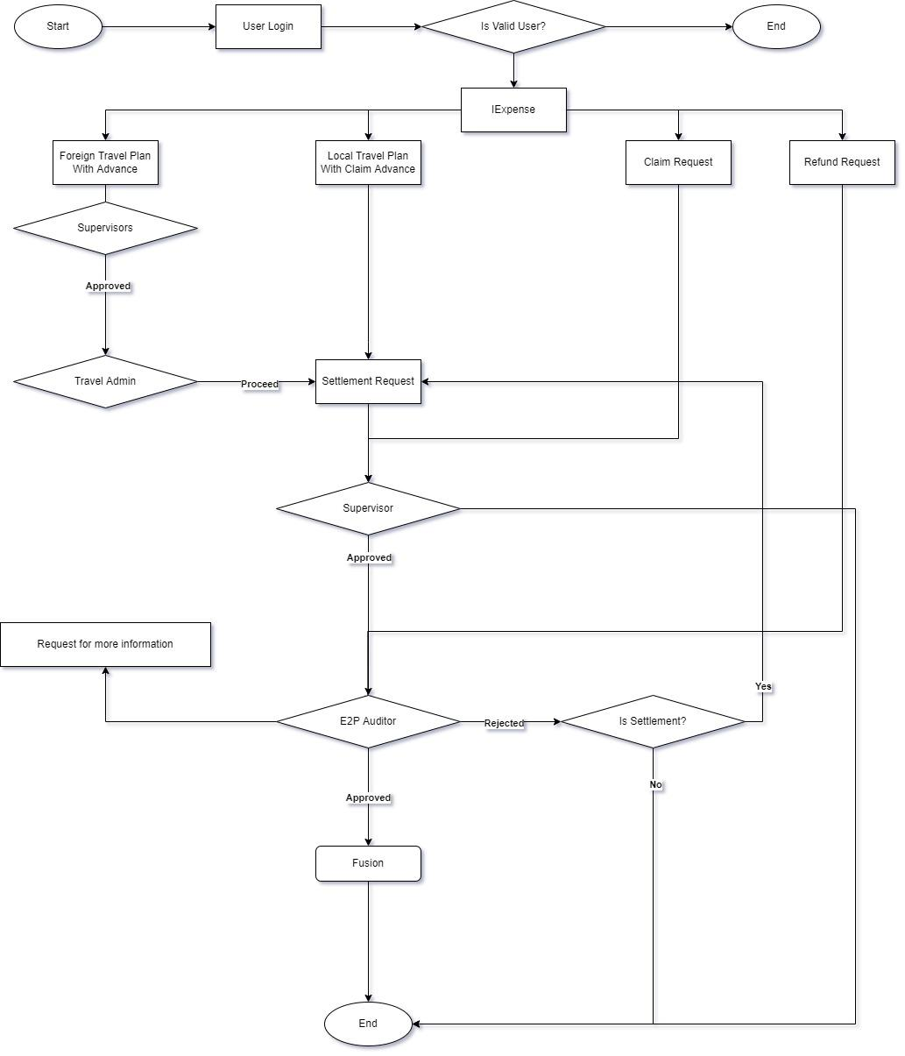

**Figure 01: Business process of iExpense**

**3.2 Database Diagram**

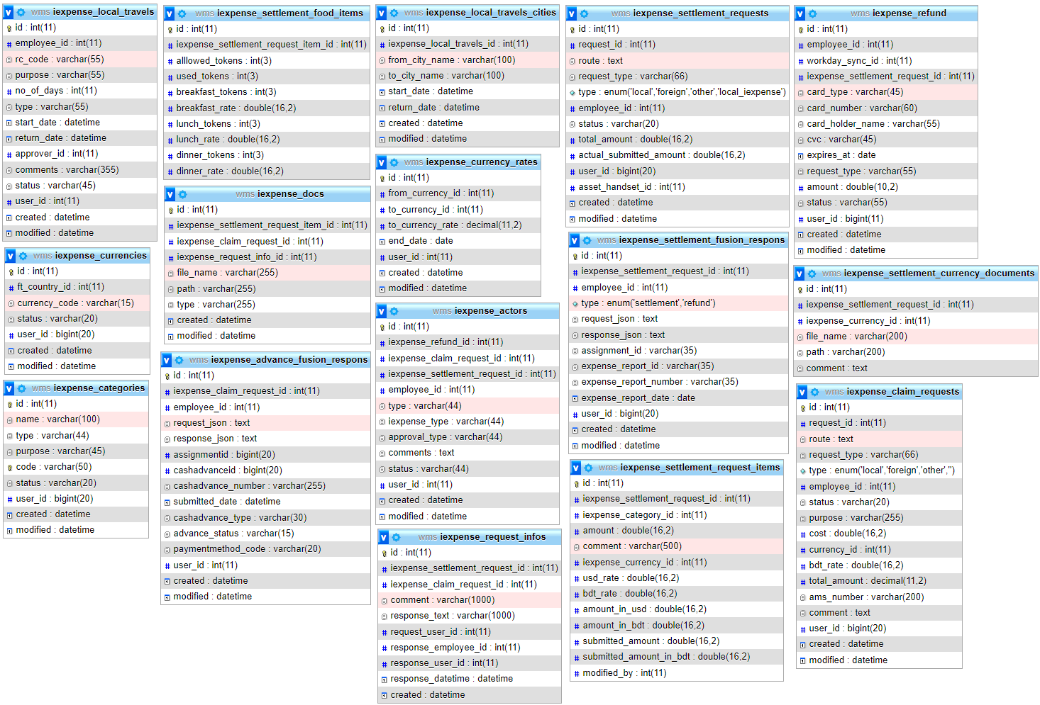

**Figure 02: Database Diagram**

**3.3 Unified Model Diagram**

**3.3.1 Class Diagram**

**Class diagram for iExpense (Android)**

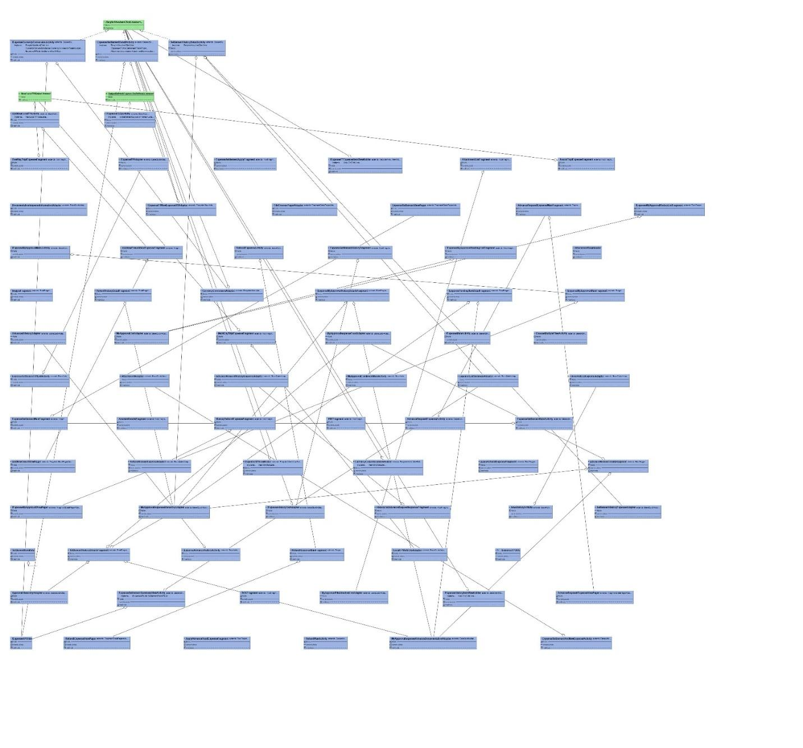

**Figure 3.3.1: Class Diagram for IExpense (Android)**

**3.3.2 USE CASE Diagram for IExpense**

**Figure 3.3.2: Use Case Diagram**

**3.3.3 Sequence Diagram**

**3.3.3.1 Sequence diagram for iExpense**

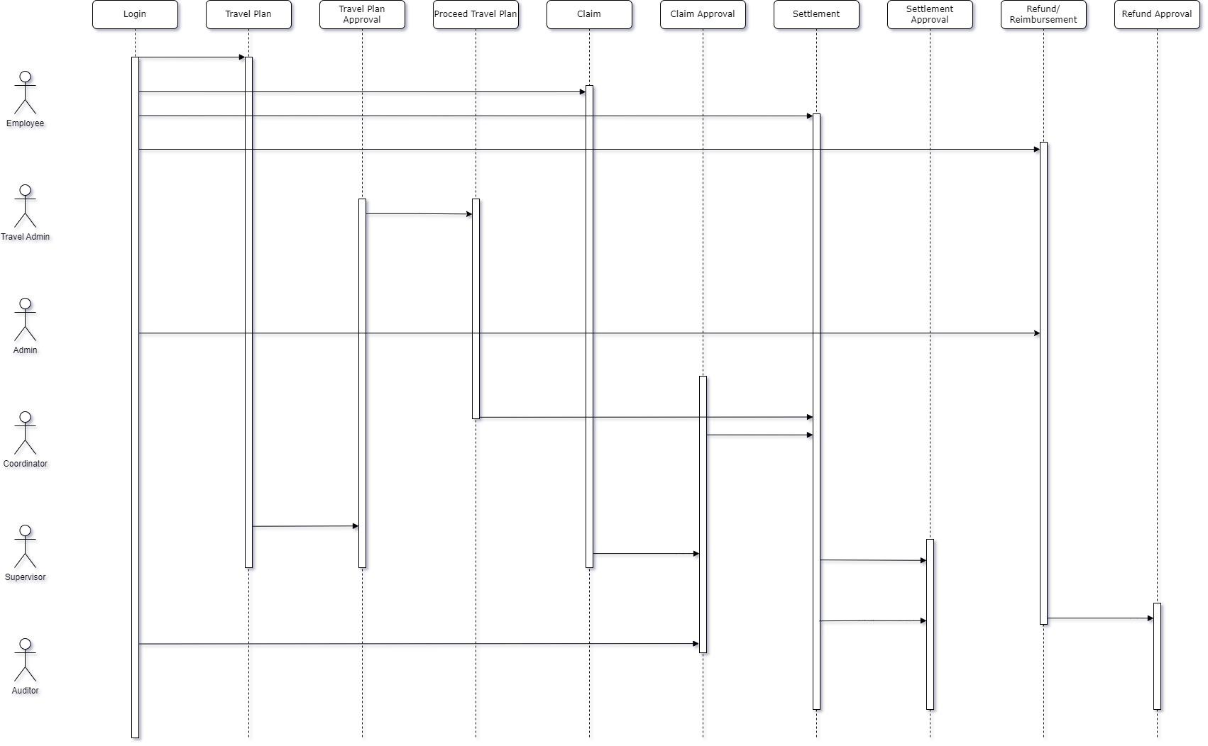

**Fig 3.3.3: Sequence diagram for iExpense**

**3.4 Prototype Design**

**3.4.1 Travel Plan and Advance Claim**

For this module, the Employee can raise a travel plan along with that request for an advance. There are three types of claims. Local, foreign, and other advances. And can plan for foreign and local.

**3.4.1.1 Process Flow**

**Web:**

**Local Travel:**

* 1. Login to OneGP web application
  2. Employees can request an advance for local travel from a local travel plan from IExpense -> Employee -> Local Travel Plan.
  3. An employee can add one/multiple local travel after going to IExpense -> Employee -> Local Travel Plan->New Local Travels. Then the employee must provide proper information and click the submit button to confirm local travel. The local travel will set in a particular date or within a date range. departure city and destination city will be auto populated in the expense settlement.
  4. Employees can edit local travel mini or local travel plan before the expense settlement’s approval.
  5. While editing local travel an employee can add/edit/delete hotel and ticket. After any changes in adding hotel/ticket or editing hotel/ticket, it will be returned to travel bucket.
  6. Place a settlement request from IExpense->Employee->LT Settlement request against the plan. Settlement in draft state can be editable.
  7. Approver can approve or reject the request.
  8. After the approvement from the approver, an auditor approves or rejects the advance from IExpense -> E2P Auditor or can edit the advance. But the advance amount couldn’t be bigger the number employee claimed and attachment will be replace if auditor submit one.

**3.4.1.1.1 DB Operation**

|  |  |
| --- | --- |
| **Table Name** | **Change Type** |
| wf_issues | Old Table |
| wf_workflow_transitions | Old Table |
| travel_tickets | Old Table |
| travel_accomodations | Old Table |
| iexpense_settlement_requests | Old Table |
| iexpense_settlement_request_items | Old Table |
| iexpense_settlement_food_items | Old Table |
| iexpense_docs | Old Table |
| iexpense_actors | Old Table |
| iexpense_settlement_currency_documents | Old Table |
| iexpense_request_infos | New Table |
| iexpense_settlement_fusion_respons | Old Table |

**Foreign Travel:**

* 1. Employees can request an advance for foreign travel from a foreign travel plan from Foreign Travel -> My Requisitions
  2. After completing all approvement of employee’s approvers Foreign Travel request goes to the travel admin’s list where the travel admin proceeds with the request and the foreign travel request goes for settlement.
  3. The advance amount is approved or rejected by the approver.
  4. After the approvement from the approver, an auditor approves or rejects the advance from IExpense -> E2P Auditor or can edit the advance. But the advance amount couldn’t be bigger the number employee claimed and attachment will be replace if auditor submit one.

**3.4.1.1.2 DB Operation**

|  |  |
| --- | --- |
| **Table Name** | **Change Type** |
| ft_actors | Old Table |
| ft_admin_docs | Old Table |
| ft_airports | Old Table |
| ft_cities | Old Table |
| ft_costs | Old Table |
| ft_countries | Old Table |
| ft_docs | Old Table |
| ft_expenses | Old Table |
| ft_hotels | Old Table |
| ft_passengers | Old Table |
| ft_requests | Old Table |
| ft_travel_cities | Old Table |
| Passports | Old Table |
| iexpense_settlement_requests | Old Table |
| iexpense_settlement_request_items | Old Table |
| iexpense_settlement_food_items | Old Table |
| iexpense_docs | Old Table |
| iexpense_actors | Old Table |
| iexpense_settlement_currency_documents | Old Table |
| iexpense_settlement_fusion_respons | Old Table |
| iexpense_request_infos | New Table |

**Other Settlement:**

* 1. Login to OneGP web application
  2. Place a new settlement request from IExpense->Employee->Other Settlement request.
  3. Approver can approve or reject the request
  4. After the approvement from the approver, an auditor approves or rejects the advance from IExpense -> E2P Auditor or can edit the advance. But the advance amount couldn’t be bigger the number employee claimed and attachment will be replace if auditor submit one.

**3.4.1.1.3 DB Operation**

|  |  |
| --- | --- |
| **Table Name** | **Change Type** |
| iexpense_settlement_requests | Old Table |
| iexpense_settlement_request_items | Old Table |
| iexpense_settlement_food_items | Old Table |
| iexpense_docs | Old Table |
| iexpense_actors | Old Table |
| iexpense_settlement_currency_documents | Old Table |
| iexpense_request_infos | New Table |
| iexpense_settlement_fusion_respons | Old Table |

**Other Advance:**

* 1. An employee can request other advances from IExpense -> Employee -> Advance Claim. Admin can request other advances on behalf of an employee from IExpense -> Admin -> Advance Claim
  2. The advance amount is approved or rejected by the approver.
  3. After the approvement from the approver, an auditor approves or rejects the advance from IExpense -> E2P Auditor or can edit the advance. But the advance amount couldn’t be bigger the number employee claimed and attachment will be replace if auditor submit one.

**3.4.1.1.3 DB Operation**

|  |  |
| --- | --- |
| **Table Name** | **Change Type** |
| iexpense_claim_requests | Old Table |
| iexpense_docs | Old Table |
| iexpense_actors | Old Table |
| iexpense_advance_fusion_respons | Old Table |

**Mobile:**

* 1. Login OneGP application via Android or IOS
  2. From navigation, the user can redirect the “Travel plan & Expense” module.
  3. To claim a request for local advance, the user can add a travel request with advance.
  4. To claim an advance request for foreign travel, the user can add a request from the foreign module with advance.
  5. To claim an advance request for any other purpose, the user can raise a request from the other advance section.
  6. After submitting a request successfully, the supervisor will be able to see the request and can Approve/Reject the request.
  7. After the supervisor’s approval, the auditor will be able to see the request and can Approve/Reject the request.
  8. The auditor requests more information to the employee raised the settlement if it’s necessary from the settlement detail.
  9. After the auditor’s approval, fusion will be called.
  10. From the web employee will be able to submit other advance claims for themselves.

**3.4.1.2 DB Operation**

|  |  |
| --- | --- |
| **Table Name** | **Change Type** |
| iexpense_claim_requests | Old Table |
| iexpense_advance_fusion_respons | Old Table |

**3.4.2 Settlement**

To use this feature, the user can settle the expenditure during his travel period.

**3.4.2.1 Process Flow**

* 1. A User needs to add the expense head, amount, and the billing document of expense
  2. The coordinator can do it on behalf of the user the employees tagged with him/her.
  3. If the user settles the request for foreign travel, he/she needs to attach all the currency documents and input the currency conversion rate.
  4. If the user doesn’t take the advance and needs to settle the expenditure of local travel, he can add a travel request from the local travel settlement section
  5. Local, Foreign and other settlements can only be submitted by the employee and by its coordinator from IExpense -> Coordinator menu
  6. Local travel settlement can be done multiple times.
  7. After submitting a request successfully, the supervisor can see the request and can Approve/Reject the request approve or reject the settlements from IEexpense -> Supervisor menu.
  8. After the supervisor’s approval, the auditor will be able to see the request and can Approve/Reject the request from IExpense -> E2P Auditor menu.
  9. Supervisor can request for information and employee will response with the document.
  10. After the supervisor’s approval, fusion will be called.

**3.4.2.2 DB Operation**

|  |  |
| --- | --- |
| Table Name | Table Type |
| iexpense_settlement_requests | New_table |
| iexpense_settlement_request_items | New_table |
| iexpense_settlement_food_items | New_table |
| iexpense_settlement_currency_documents | New_table |
| iexpense_docs | New_table |
| iexpense_settlement_fusion_respons | New_table |
| iexpense_request_infos | New table |

**3.4.3 Refund**

To use this feature, the user can refund the advance money after settlement or before settlement.

**3.4.3.1 Process Flow**

1. The user needs to give the amount which he needs to refund. The employee can do it for themselves from the web.
2. After giving the amount, he/she will get two options. A)Express Card B) Other Card
3. By choosing other card, the user needs to give all the information about other card. Ex: cardholder name, card no, expires at
4. After submitting a request successfully, the auditor will be able to see the request and can Approve/Reject the request.
5. After auditors, fusion will be called.
6. Admin can adjust advance salary from refund.

**3.4.3.2 DB Operation**

|  |  |
| --- | --- |
| **Table Name** | **Table type** |
| iexpense_refund | New_table |

**3.4.4 Reimbursement**

**3.4.4.1 Process Flow**

1. If the expenditure is greater than the advance balance, then the amount will automatically reimburse to the user's account.

**3.4.5 Employee tagging**

1. Admin will tag employees to a coordinator. The coordinator will settle FT, LT, and Other of the employees tagged with him/her. He/She will also be able to do foreign requests.

**3.4.5.1 DB Operation**

|  |  |
| --- | --- |
| **Table Name** | **Table type** |
| employees_coordinators | New_table |

* + 1. **Request for Information**

**3.4.6.1 Process Flow**

1. Supervisor can request information from to IExpense -> Supervisor -> Settlement Requests. Then the supervisor will go to details and find Request for Information. Then the supervisor can attach previous information and comment if there any information is required and submit request.

2. User can respond to a request of a supervisor in settlement

3. E2P auditor can request information from to IExpense -> E2P Auditor -> Settlement Requests. Then the E2P auditor will go to details and find Request for Information. Then the E2P auditor can attach previous information and comment if there any information is required and submit request.

4. User can respond to a request of an E2P auditor in settlement

**3.4.6.2 DB Operation**

|  |  |
| --- | --- |
| **Table Name** | **Table type** |
| iexpense_request_infos | New_table |

**App.php :**

'iexpense_attachments' => [ROOT . DS . 'uploads' . DS . 'iexpense' . DS]

**Email Template Slugs:**

iexpense-cash-advance-notification

settlement-information-request-notification

**Config:**

Name: IExpense

Key: iexpense-config

Value:

{

"cxo": [

"27409",

"123456",

"25546",

"25404"

],

"ceo": [

"27409"

],

"cfo": 25567,

"expense-head": "Expense Settlement",

"expense-head-template-id": "300000002275105",

"launching-date": "2018-01-01",

"fusion_advance": {

"url": "http:\/\/10.10.23.191:8011\/CashAdvanceV1",

"local": "Local Travel",

"foreign": "Foreign Travel",

"other": "Other Advance",

"type_test": "Other Travel",

"test_id": "864325"

},

"file-upload-limit": {

"maxnumber": 5,

"maxsize": 10

},

"advance-notification": {

"mindays": 35,

"maxdays": 90,

"settled": "14th"

},

"trip_types": {

"One Way": "One Way",

"Round Trip": "Round Trip",

"Multi City": "Multi City"

},

"expense-type": {

"foreign": {

"business": {

"template_code": 300000002275183,

"name": "Foreign Travel Expense - Business"

},

"training": {

"template_code": 300000002275456,

"name": "Foreign Travel Expense - Training"

}

},

"local": {

"template_code": 300000002275461,

"name": "Local Travel Expense"

},

"other": {

"template_code": 300000002275462,

"name": "Other Expense"

}

},

"local": {

"breakfast": {

"startTime": "00:00",

"endTime": "12:00",

"rate": "150"

},

"lunch": {

"startTime": "12:00",

"endTime": "18:00",

"rate": "425"

},

"dinner": {

"startTime": "18:00",

"endTime": "24:00",

"rate": "425"

}

},

"foreign_asia": {

"breakfast": {

"rate": "20"

},

"lunch": {

"rate": "35"

},

"dinner": {

"rate": "40"

}

},

"foreign_europe": {

"breakfast": {

"rate": "25"

},

"lunch": {

"rate": "40"

},

"dinner": {

"rate": "60"

}

},

"other_advance": {

"max_cost": "20000"

},

"purposes": [

"Vendor meeting",

"Human Interaction",

"Training",

"Others"

],

"date_format": {

"date": "d-M-Y",

"time": "h:i A"

}

}

**Access Permission**

|  |  |  |  |
| --- | --- | --- | --- |
| **Module** | **Permission Group** | **Access Root** | **Actions** |
| IExpense | Admin | SettlementRequests | All |
|  | IExpense Admin | ClaimRequests | auditorEdit  auditReport  actionsApprover  add  auditApprover  auditReport  download  index  indexAuditor  reportAuditorApproval  view  viewAuditor  viewAuditorReport |
| Categories | add  edit  index  view |
| Currencies | add  delete  edit  index  view |
| CurrencyRates | Add  Edit  Index |
| InformationRequests | add  edit |
| LocalTravels | add  autocomplete  edit  index  view |
| Refund | actionsAuditor  actionsManager  add  findcard  index  indexAuditor  indexManage  reportAuditor  reportReimbursement  viewAuditor  viewManage |
| SettlementRequests | actionsApprover  actionsAuditor  addForeign  addForeignManage  addManageLocal  addOthersManage  download  editApproverForeign  editApproverLocal  editAuditorForeign  editAuditorLocal  editForeign  editForeignManage  editManageLocal  editOthersApprover  editOthersAuditor  editOthersManage  indexApproveForeignTravel  indexApprover  indexAuditor  indexLocalManage  indexManageForeign  indexManageLocal  indexOthersManage  manualFusionCall  report  reportAuditorApproval  viewApproverForeign  viewApproverLocal  viewApproverOthers  viewAuditorForeign  viewAuditorLocal  viewForeign  viewForeignManage  viewFusionDetail  viewManageLocal  viewOthers  viewOthersAuditor  viewOthersManage |
|  | IExpense Auditor | ClaimRequests | auditorApprover  auditorEdit  auditReport  download  indexAuditor  reportAuditorApproval  viewAuditor  viewAuditorReport |
| InformationRequests | add  edit |
| Refund | actionsAuditor  add  balance  findcard  indexAuditor  reportAuditor  reportReimbursement  viewAuditor |
| SettlementRequests | actionsAuditor  additionalAttachments  deleteAttachment  download  editAuditorForeign  editAuditorLocal  editOthersAuditor  indexAuditor  manualFusionCall  reportAuditorApproval  viewAuditorForeign  viewAuditorLocal  viewOthersAuditor |
| IExpense | Employee | ClaimRequests | actionsApprover  addAdvanceRequestSelf  index  selfRequests  view  viewSelf |
| settlementRequests | actionsApprover  addEmployeeForeign  addEmployeeLocal  addOthersManageSelf  deleteAttachment  download  editEmployeeForeign  editEmployeeLocal  editOthersManageSelf  indexApproveForeignTravel  indexApprover  indexEmployeeForeign  indexEmployeeLocal  indexOthersManageSelf  viewApproverForeign  viewApproverLocal  viewApproverOthers  viewEmployeeForeign  viewEmployeeLocal  viewOthersManageSelf |
| LocalTravelPlans | add  index  view |
| LocalTravels | addLocalTravelSelf  selfRequests  viewSelf |
| Refund | actionsManager  add  addSelf  findcard  index  indexManage  indexManageSelf  viewManage |
| InformationRequests | edit |
|  | Employee Co-ordinator | settlementRequests | indexCoordinateForeign  addForeignManage  viewCoordinateForeign  editForeignManage  indexCoordinateLocal  viewCoordinateLocal  editManageLocal  addManageLocal  addOthersManageCoordinator  editOthersManageCoordinator |
| Ft | printTp  add  getPassports  indexCoordinator  view |
|  | Auditor | ClaimRequests | indexAuditor  auditorApprover |
| settlementRequests | indexAuditor  viewAuditorLocal  viewOthersAuditor  viewAuditorForeign  editAuditorLocal  editOthersAuditor  editAuditorForeign  additionalAttachments  actionsAuditor |
| InformationRequests | add |
| Refund | indexAuditor  viewAuditor  actionsAuditor |
| Ft | Employee | Requests | addSelf  approverHistory  cancel  downloadFile  indexApprover  indexHistory  view |
| Employee Coordinator | Actors | printTp |
| Requests | add  getPassports  indexCoordinator  view |

* 1. **Server Architecture**

Below Figure represents, how user and server is interacting with each other for mating data communication.

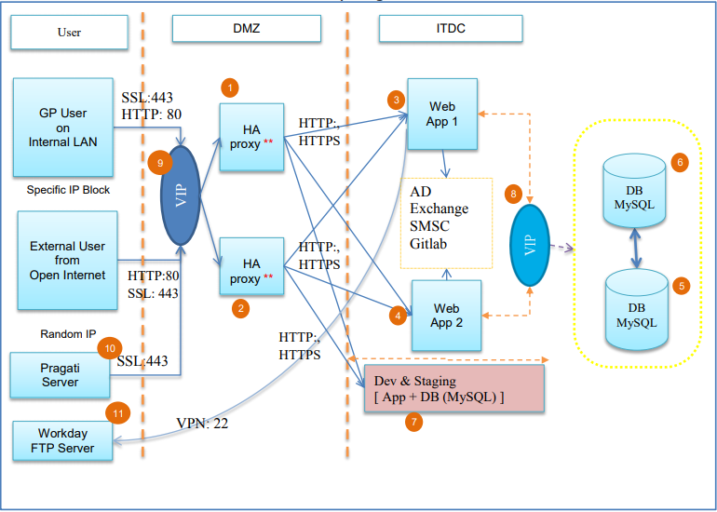

*Fig. 05: Server architecture for OneGP*

Following are the description of numbers at server architecture figure #05.

1. Porxy + Load balancer
2. Porxy + Load balancer
3. App/web server
4. App/web server
5. DB primary
6. DB standby
7. Dev + Staging server
8. VIP: Virtual IP between DB
9. VIP: Virtual IP between LB
10. Pragati VM
11. Workday FTP Server

### **Technical Standards**

|  |  |  |
| --- | --- | --- |
| **Technology** | **Database** | **Server** |
| Apache | MySQL DB | Apache |
| PHP |  |  |
| CakePHP3 |  |  |
| MVC |  |  |
| HTML5/CSS/Bootstrap |  |  |
| JavaScript/JQuery |  |  |

*Table 08: Technical Standard*

### **Page Controls**

|  |  |
| --- | --- |
| **Control Name** | **Description** |
| Date picker | select a date range |
| Label | Text Information |
| Button | Action to populate table data |
| Table | To display the report data |
| Hyperlink | To open new window or upload excel file |
| Dropdown | to populate list of data |
|  |  |

*Table 09: Page controls*

# **Traceability to Requirements**

List traceability information to trace the requirements from RS document to Design document.

The locations of design specifications should be mapped to the corresponding locations of the requirements in the RS document.

|  |  |  |
| --- | --- | --- |
| **Document reference Id & Description: (Doc Id from which this document is derived)** | | |
| **Sl No.** | **Reference document**  **Requirement/Feature (Section ID/Name)** | **Design document**  **(Section ID/Name)** |
|  |  |  |

# **Others**

Describe other items like reusable components etc.

# **Acronyms and Glossary**

|  |  |
| --- | --- |
| DMZ | Demilitarized Zone |
| HA | High-availability |
| ITDC | IT Data center |
|  |  |
|  |  |
|  |  |
|  |  |
|  |  |